**Practical 8: Design a webpage to demonstrate the working of parameterized stored procedure**.

**📌 Steps to Implement**

1. **Create a SQL Server Database** with a stored procedure.
2. **Design an ASP.NET Web Form** using Visual Studio.
3. **Use ADO.NET to call the stored procedure** from C#.
4. **Display the output on the webpage.**

**1️ SQL Server: Create a Database & Stored Procedure**

Run the following SQL commands in **SQL Server Management Studio (SSMS):**

CREATE DATABASE EmployeeDB;

USE EmployeeDB;

-- Create Table

CREATE TABLE Employees (

EmpID INT PRIMARY KEY IDENTITY(1,1),

Name VARCHAR(100),

Department VARCHAR(100),

Salary DECIMAL(10,2)

);

-- Insert Sample Data

INSERT INTO Employees (Name, Department, Salary)

VALUES ('John Doe', 'IT', 60000), ('Jane Smith', 'HR', 55000);

-- Create Stored Procedure to Fetch Employee Data by Department

CREATE PROCEDURE GetEmployeesByDepartment

@DepartmentName VARCHAR(100)

AS

BEGIN

SELECT * FROM Employees WHERE Department = @DepartmentName;

END;

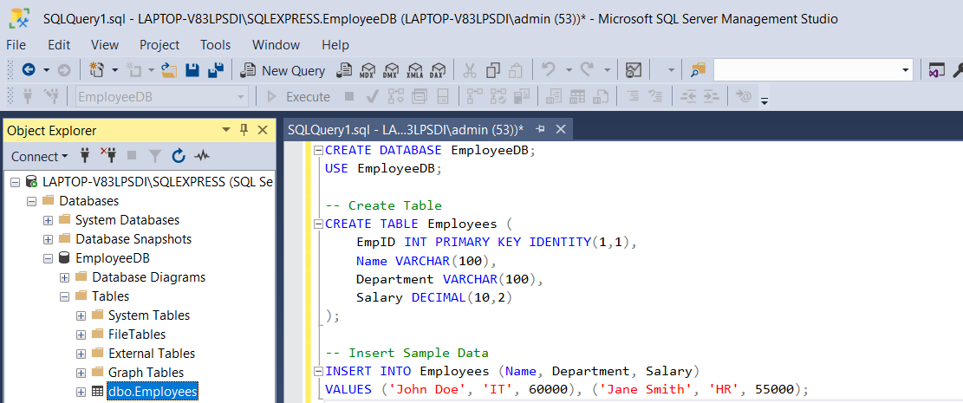

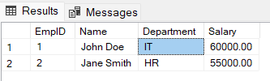

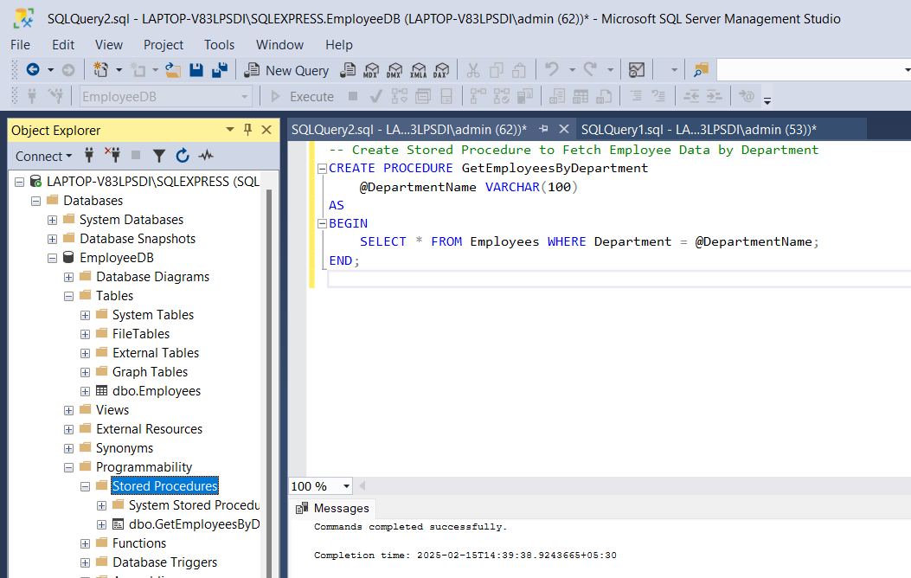

**2️ Create ASP.NET Web Form**

**🔹 Design a Web Form (**WebForm1**.aspx)**

Go to **Visual Studio** → **ASP.NET Web Forms Application** and modify WebForm1.aspx as follows:

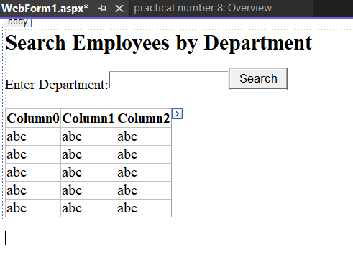

<%@ Page Language="C#" AutoEventWireup="true" CodeBehind="WebForm1.aspx.cs" Inherits="practical_number_8.WebForm1" %>

<!DOCTYPE html>

<html lang="en">

<head runat="server">

<title>Stored Procedure Demo</title>

</head>

<body>

<form id="form1" runat="server">

<div>

<h2>Search Employees by Department</h2>

<asp:Label runat="server" Text="Enter Department:"></asp:Label>

<asp:TextBox ID="txtDepartment" runat="server"></asp:TextBox>

<asp:Button ID="btnSearch" runat="server" Text="Search" OnClick="btnSearch_Click"/>

<br /><br />

<asp:GridView ID="gvEmployees" runat="server" AutoGenerateColumns="True"></asp:GridView>

</div>

</form>

</body>

</html>

**3️ Backend Code (Default.aspx.cs)**

Modify WebForm1.aspx.cs to call the **stored procedure using ADO.NET**.

using System;

using System.Configuration;

using System.Data;

using System.Data.SqlClient;

using System.Web.UI;

namespace practical_number_8

{

public partial class WebForm1 : System.Web.UI.Page

{

protected void Page_Load(object sender, EventArgs e)

{

}

protected void btnSearch_Click(object sender, EventArgs e)

{

string connStr = "Data Source=LAPTOP-V83LPSDI\\SQLEXPRESS;Initial Catalog=EmployeeDB;Integrated Security=True";

{

SqlConnection conn = new SqlConnection(connStr);

SqlCommand cmd = new SqlCommand("GetEmployeesByDepartment", conn);

cmd.CommandType = CommandType.StoredProcedure;

cmd.Parameters.AddWithValue("@DepartmentName", txtDepartment.Text);

SqlDataAdapter da = new SqlDataAdapter(cmd);

DataTable dt = new DataTable();

da.Fill(dt);

gvEmployees.DataSource = dt;

gvEmployees.DataBind();

}

}

}

}



